TEAM 2: Sagar Bains, Sahej Gill, Yuejun Liu, Yujia Shen, Yuying Zhang

ISTM660

FALL 2022

**ROW64 Assignment**

Figure 1: VALE ROE(Avg) by Date

Figure 2: VALE Profit Margin by Date

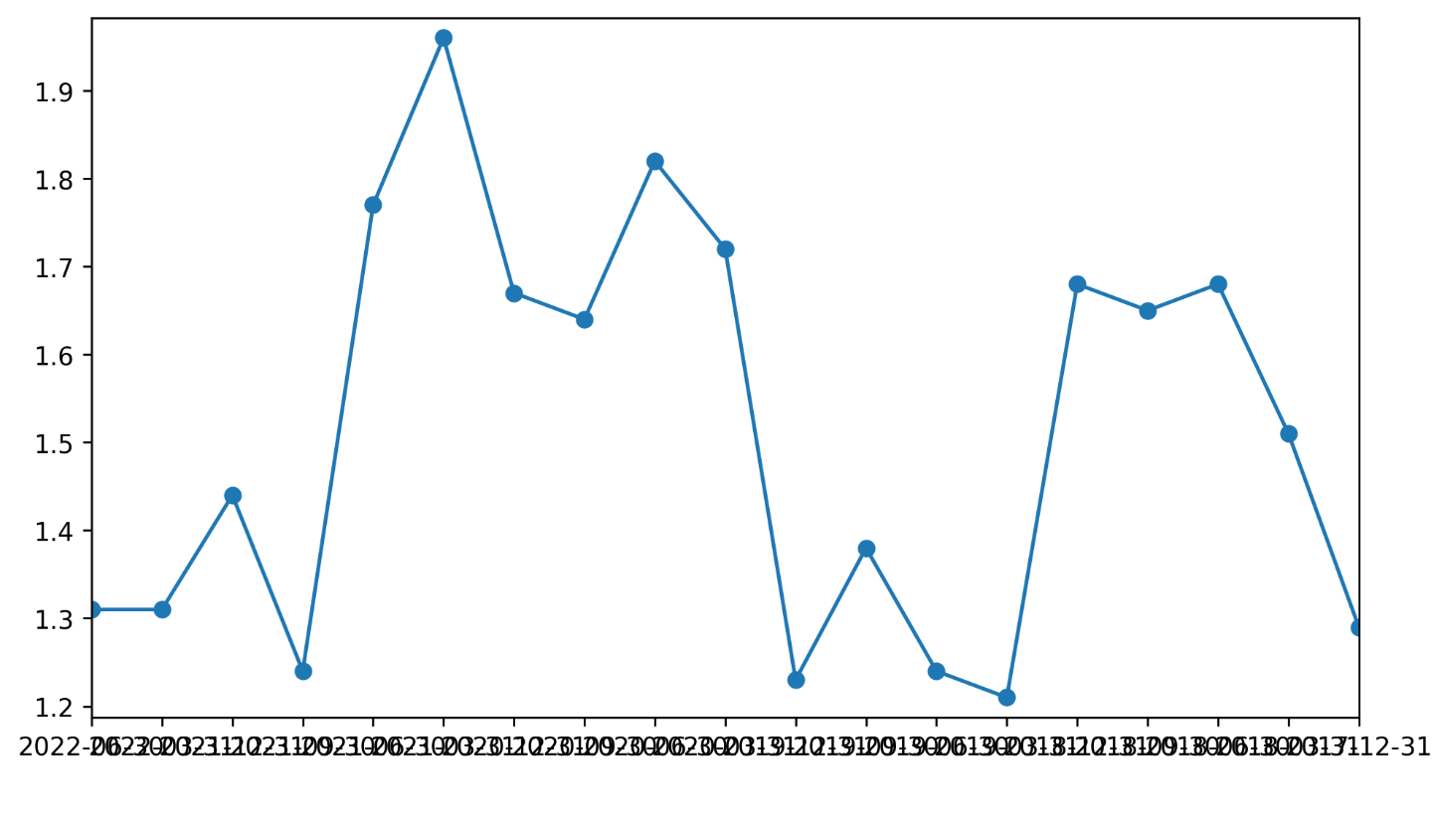

Figure 3: VALE Current Ratio by Date